Home delivered meals
Summary points to remember
- Home delivered meals can be useful if you do not enjoy cooking or find it difficult to shop, cook or leave the house
- Many services are available. Look for one that meets your dietary, taste, price and delivery needs

This document should not replace the advice of your relevant health care professional.

What are home delivered meals?
You may be able to have meals delivered to your home by your local council or by private companies. Not all companies are listed in this handout. We suggest you look into your local options. Consider:
- Fresh or frozen- Meals delivered fresh will need to be eaten in a short time frame. Frozen meals may give you more options with fewer deliveries.
- Delivery schedule - You may choose a regular delivery time such as daily, or twice a week. You can order meals as you need them, such as when a family member is away.
- Cost - You may have access to discounts or meals with help from the Government. It is important to talk about this with the service before you make an order.
- Special diets – Some services may be able to give you special meals for health conditions such as diabetes, kidney disease or if you have swallowing difficulties.

Meals on Wheels
You may be able to get Meals on Wheels meals if you are over the age of 65 or have a disability, and are having difficulty making your meals.
Delivery: Australia wide. Most councils deliver on all weekdays with some also on weekends.
Cost: The price is around $10 and meals usually include a soup, main meal, dessert and juice.
Special Diets: Vary between councils but commonly include diabetic, gluten-free, low fat or texture-modified options.
There are different ways to access Meals on Wheels meals.
If you are over 65 years of age contact My Aged Care and they can help to see if you are able to get these meals. Visit myagedcare.gov.au or call 1800 200 422. You can also speak to your local council.
If you have a disability call your local council to access Meals on Wheels.

Private delivered meal services

Fresh or Frozen Supermarket Meals
Choose fresh or frozen meals with lots of colour to provide a variety of nutrients. Some popular brands are listed. You can buy these items from your supermarket in store. If you cannot go to the shop, you can buy them from the supermarket online and have them delivered.
- McCain
- Lean Cuisine
- YouFoodz
- Woolworths woolworths.com.au
- Coles coles.com.au

Able Foods
Meals: Main meals, fruit boxes, snacks and desserts
Delivery: Covers 80% of Australia. Regular meals are fresh and texture modified meals are frozen.
Minimum purchase of $90
Cost: Regular mains $12.50, Texture modified mains $15,
Special Diets: Gluten-free, vegetarian, low FODMAP, dairy-free and texture-modified (moulded pureed meals).
NDIS: Are registered with NDIS (co-payments stated).
Visit ablefoods.com.au or call 1300 123 2253

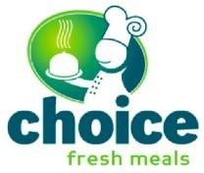
Choice Fresh Meals
Meals: Main meals, soups, breakfast options, sandwiches, desserts, bread, baked goods and milk are available.
Delivery: All meals are delivered fresh but most meals can be frozen once delivered. The delivery days depend on your suburb, usually 1-3 days per week.
Cost: Standard main meals cost between $11-16. Delivery fees and minimum orders apply.
Special Diets: Gluten free, low salt and diabetic meal options.
NDIS: Registered for NDIS.
Visit choicefreshmeals.com.au or call 1300 430 488

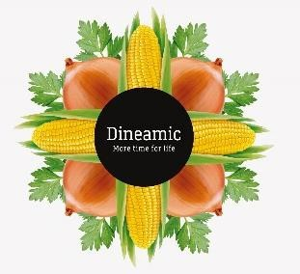
Dineamic
Meals: Large range of soups, mains, double serves, sides and snacks.
Delivery: Australia wide. Meals arrive frozen.
Cost: Main meals $10-16. Sides and soups $ 4 – 7.
Special Diets: Large selection of low FODMAP, gluten-free, dairy-free, vegetarian and vegan.
NDIS: Are registered with NDIS.
Visit dineamic.com.au or call 03 8669 0587

Katrina’s Kitchen
Meals: Main meals and desserts.
Delivery: Melbourne Metro. All meals are delivered frozen and delivery schedule depends on the suburb but is generally weekly. Meals can also be collected from their store in Murrumbeena.
Cost: Main meals are about $10. Delivery fees and minimum orders apply.
Special Diets: None stated.
NDIS: Registered for NDIS.
Visit katrinaskitchen.com.au or call 03 9569 0488

Lite n’Easy
Meals: You have the option of choosing a full day of meals and snacks or just selected meals. Delivery: Australia wide. Meals arrive either frozen or fresh.
Cost: Lunch or dinner mains start from $10 -14 but vary depending on meal plan chosen. Minimum orders apply. Delivery fees apply in some areas.
Special Diets: Some meal plans are designed for weight loss. Ask your dietitian or use the website to determine which meal plan suits your goals.
NDIS: Registered for NDIS
Visit liteneasy.com.au or call 13 15 12

Meals in a Moment
Meals: Main meals, soups, breakfast, desserts and baked goods and basic groceries.
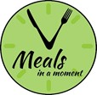
Delivery: Melbourne Metro and some regional areas. All meals are delivered frozen and delivery schedule is determined at the time of ordering.
Cost: Main meals cost between $9-13. Delivery fees and minimum orders apply.
Special Diets: Gluten-free, diabetic and texture-modified meals (pureed and minced, separate menu – call for details).
NDIS: Registered for NDIS.
Visit mealsinamoment.com.au or call 03 7036 6516

Tender Loving Cuisine
Meals: Main meals, soups and desserts.
Delivery: Greater Melbourne metro including Geelong, Mornington and Bellarine Peninsulas. All meals are delivered frozen and delivery schedule depends on the suburb but is generally weekly.
Cost: Main meals cost between $9-15.
Special Diets: Heart-friendly, dairy-free, gluten-free, diabetic, low salt and texture-modified (soft and minced only).
NDIS: Registered for NDIS.
Visit tlcmeals.com.au or call 1800 801 200.

We Feed You
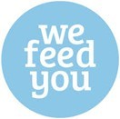
Meals: Main meals
Delivery: Delivers to NSW, VIC, QLD and ACT. Meals arrive frozen.
Cost: Meals range between $11 -16. Can buy 10 or 20 meal value pack for a reduced price.
Special Diets: All meals are Gluten Free, large range of Low FODMAP., low lactose, onion and garlic free, vegetarian, vegan and double serve meals.
NDIS: Not registered for NDIS but can provide meals for some NDIS packages.
Visit wefeedyou.com.au

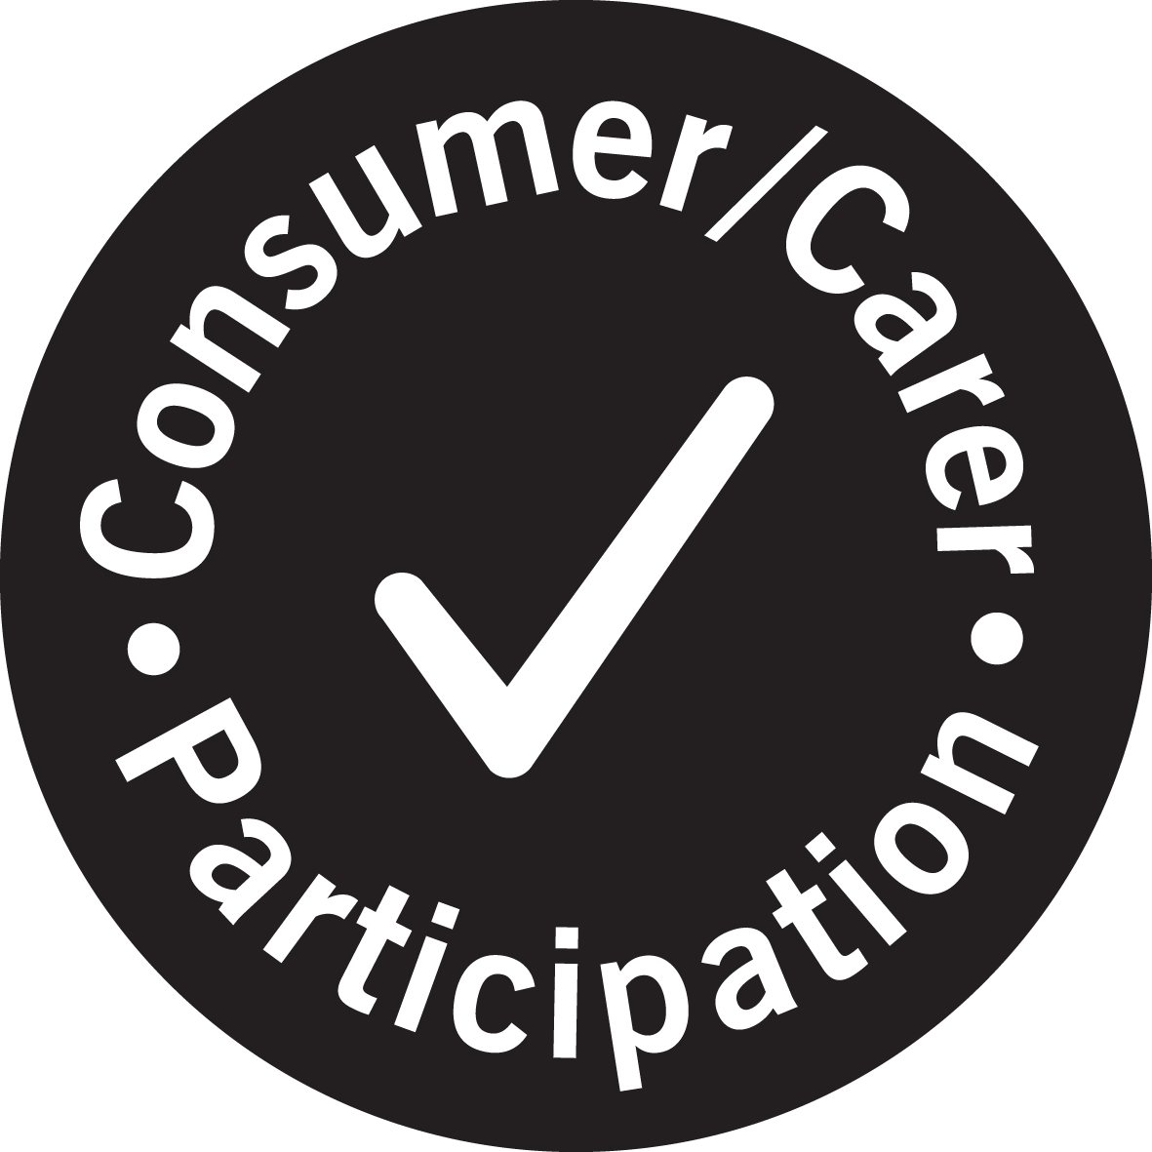

For further information
Department: Nutrition Department
Phone: 9496 5011
Date produced: October 2021
Date for review: October 2014

This document was reproduced with permission of Royal Melbourne Hospital, Nutrition and Dietetic Department.

